**Assignment 2 Upper Layers of the OSI-Model**

1. Sending emails and SMTP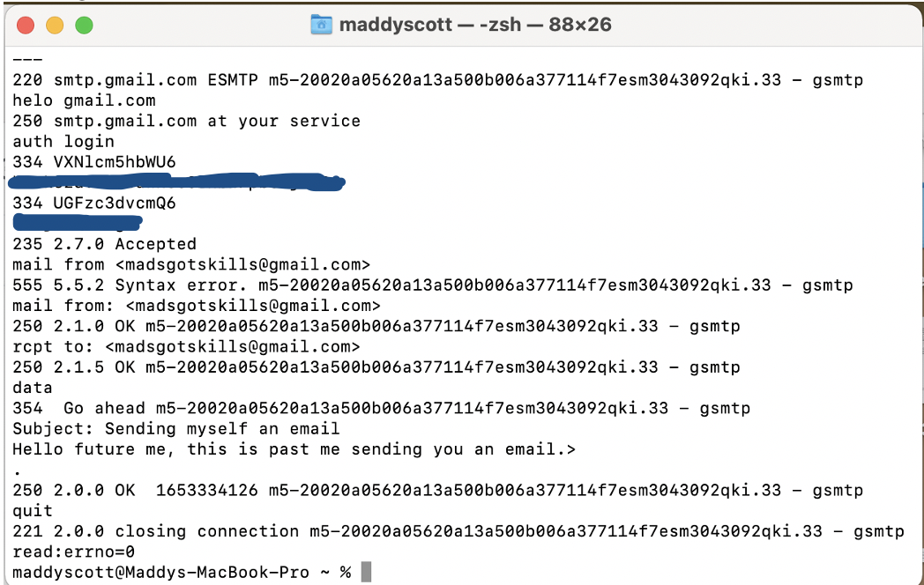

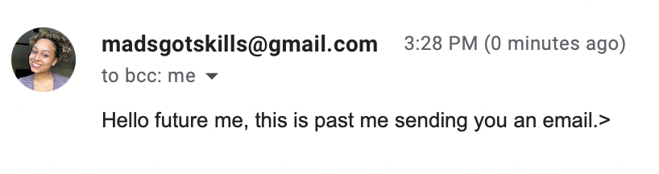

1. What filter did you use to catch the traffic? Explain why you chose that filter.
   1. I chose to use the port 465 as my filter. I did this because we used this port within our command. It is also Google’s SMTP server port, so I figured it made the most sense.
2. What is the standard port for SMTP and why do we use port 465 in the example  
   above?
   1. The standard port for SMTP is 25. Port 465 is intended for email client to email server communications. For this example, we use 465 because it is the port established for SMTP to operate using SSL.
3. Explain each line used in the command line, what it does, and why it is need.
   1. Echo -ne username | base 64 and echo -ne password | base64 converts the username and password for your email into base 64. It is needed in order to copy and paste the auth login into the command line.
   2. Openssl s_client -crlf -ign_eof -connect smtp.gmail.com:465 is used in order to establish a connection to Google’s SMTP port. This command opens and tests the ssl connect to a specific port number. This command also translates a line feed from the terminal and then tells the connect to quit when it reaches the end of the file.
   3. Helo gmail.com allows the SMTP server to identify itself and confirm the connection to Google’s SMTP server.
   4. Auth login lets the user input their user and password that was turned into base 64 in order to login to their account.
   5. Mail from :<email> allows the user to provide the address the email will be from.
   6. Rcpt to:<email> lets the user input the recipient of the email.
   7. Data lets the user provide the emails content.
   8. Subject: lets the user input the subject of the email
   9. The period “.” Used sends the email and identifies when it has ended.
   10. Quit lets you shut down the ssl connection.
4. How much back and forth communication do you see for establishing the connection
   1. I saw a total of 15 packets that were used.
5. What is the port your local machine is using between sending the two emails when  
   communicating with the SMTP server?
   1. 58612
6. Explain who sends the first FIN flag and how the quitting process works
   1. Port 465 sent the first FIN flag with an ACK. The receiver then acknowledged the ACK and follows up with a second finish and ACK. When that is returned, Gmail.com resets and ends the connection.

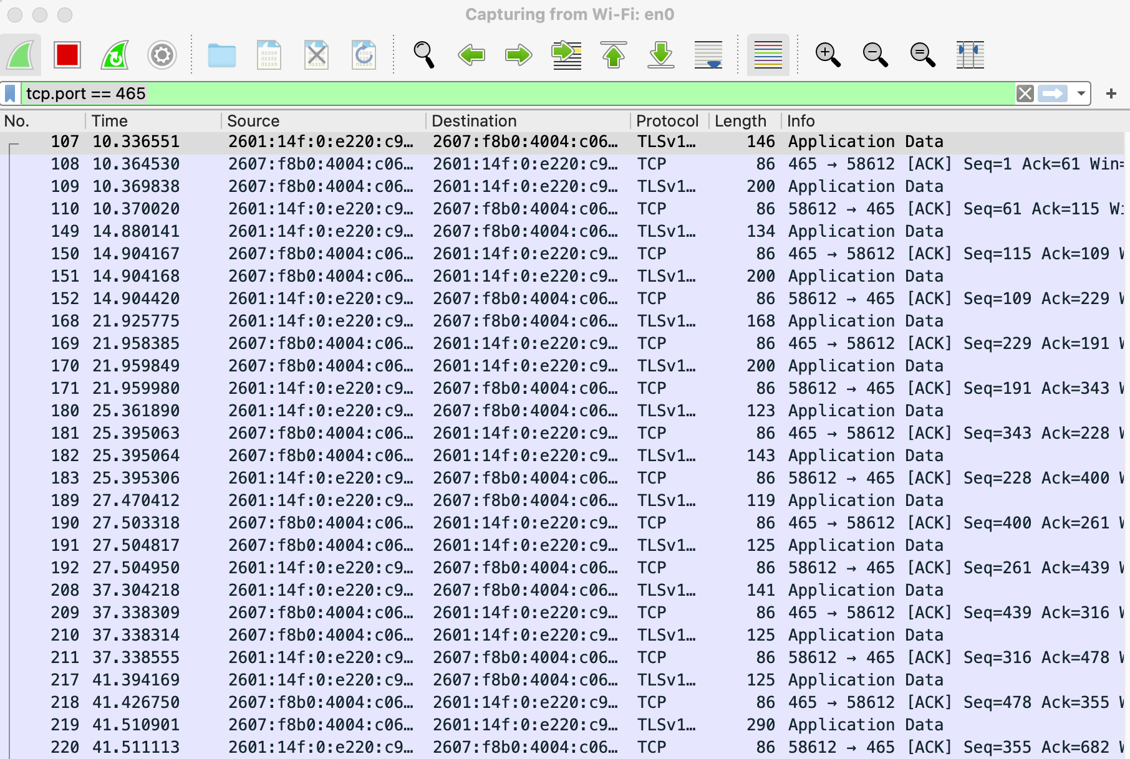

1. **Understanding HTTP**

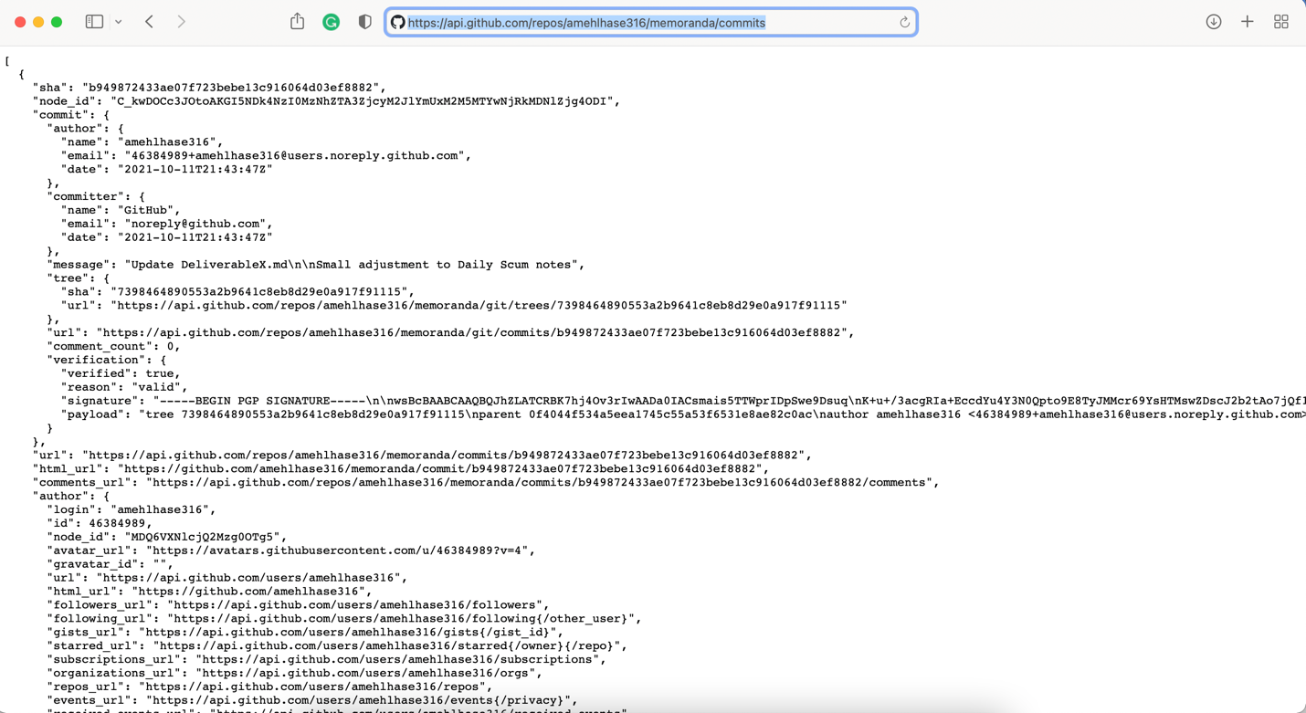

Call I used: <https://api.github.com/repos/amehlhase316/memoranda/commits>

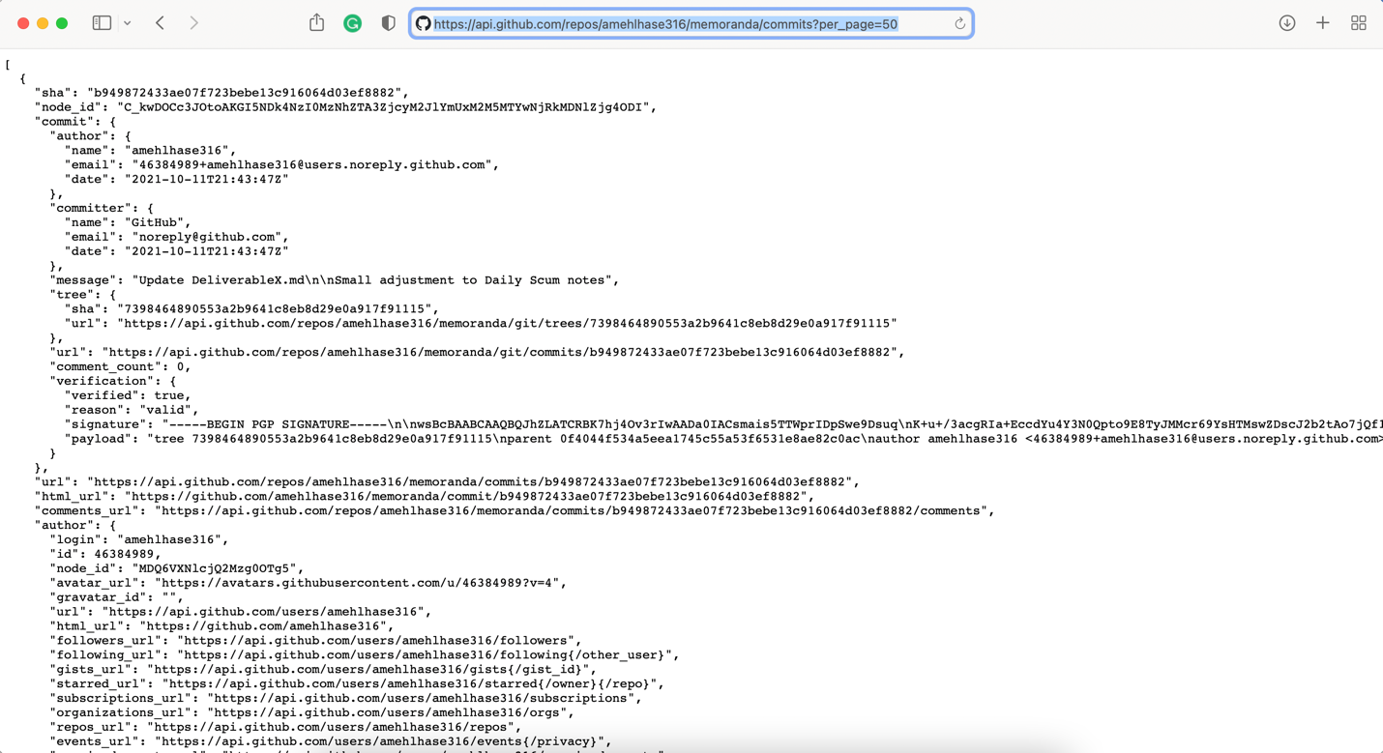

Call I used: <https://api.github.com/repos/amehlhase316/memoranda/commits?per_page=50>

1. Explain the specific API calls you used.
   1. First call I used: <https://api.github.com/repos/amehlhase316/memoranda/commits>

This call was to return the commits on this branch.

b. second call I used: <https://api.github.com/repos/amehlhase316/memoranda/commits?per_page=50>

This call made it so that the page_per limit was set to 50 instead of the default 30.

1. Explain the difference between stateless and a stateful communication
   1. A stateless communication doesn’t require that the server save anything that was sent or requested by the client. The requests are independent and there is no memory of the requests that were sent so you end up doing the whole process over again. A state-full communication requires the server to remember the data within that session, meaning you can continue communication without needing to start from the top each time.
2. **Setup your second system and run Server on it**

**3.1 Getting the sample code onto your systems** – Done

**3.2 Running a simple Java Webserver**

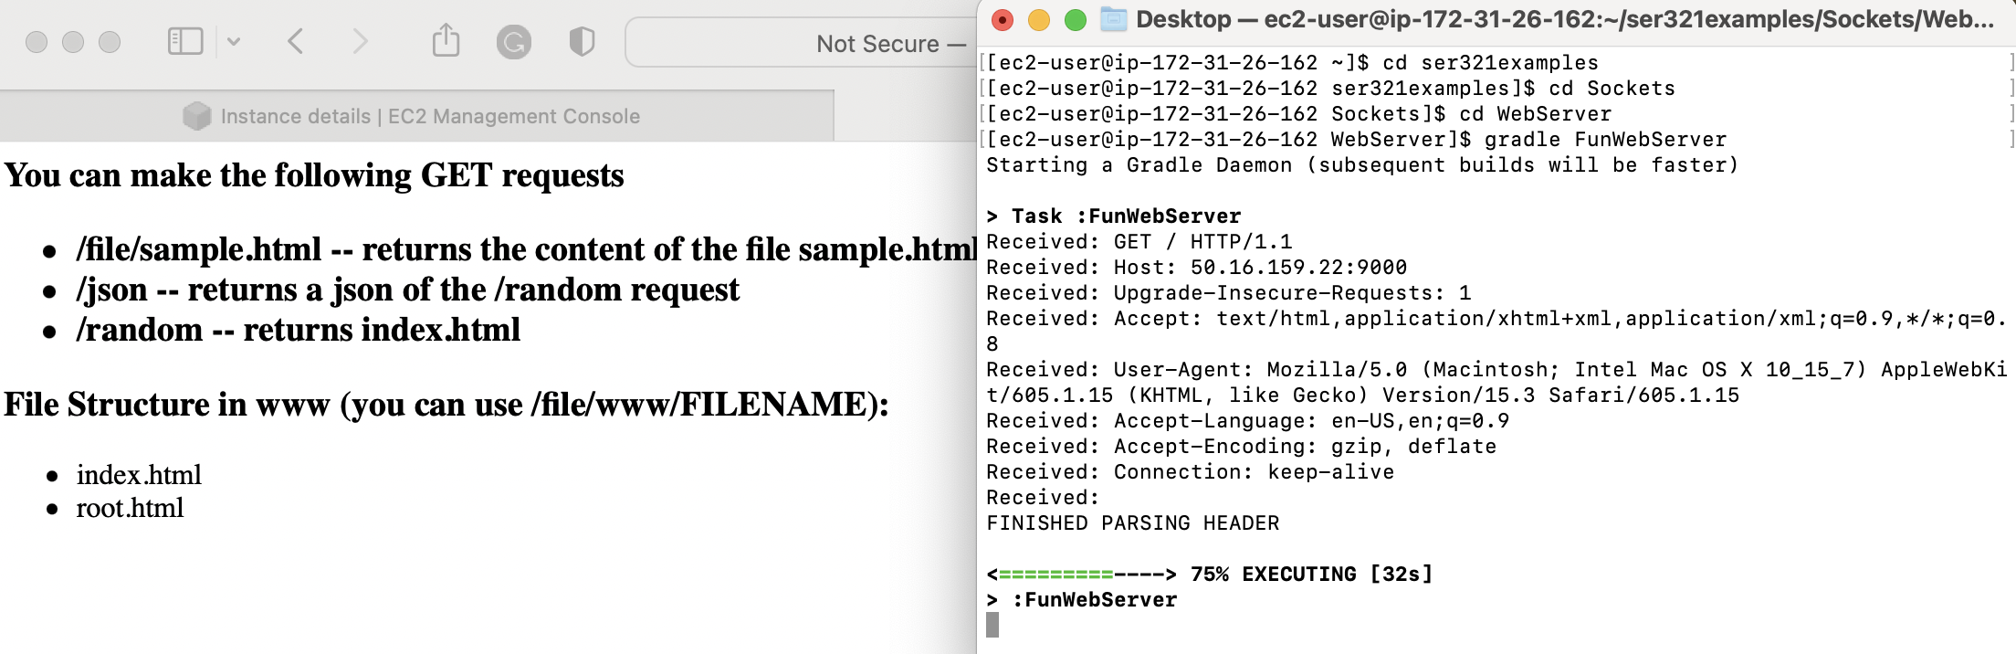

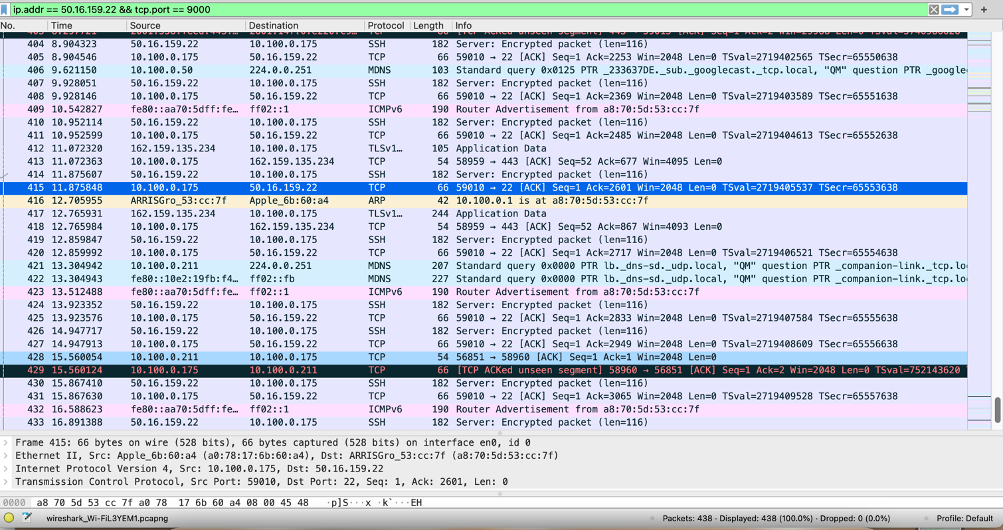

**3.3 Analyze what happens**

1. What filter did you use? Explain why you chose that filter.
   1. I filtered the data using the IP address and the tcp port. I used the IP address of my ec2 and because I used this filter, I was able to get all of the traffic through that address. I choose the port 9000 in order to narrow it down even more to my specific example. These two filters gave me a cleaner look into the traffic I needed.
2. What happens when you are on /random and click the "Random" button compared  
   to the browser refresh (you can also use the command line output that the WebServer  
   generates to answer this)?

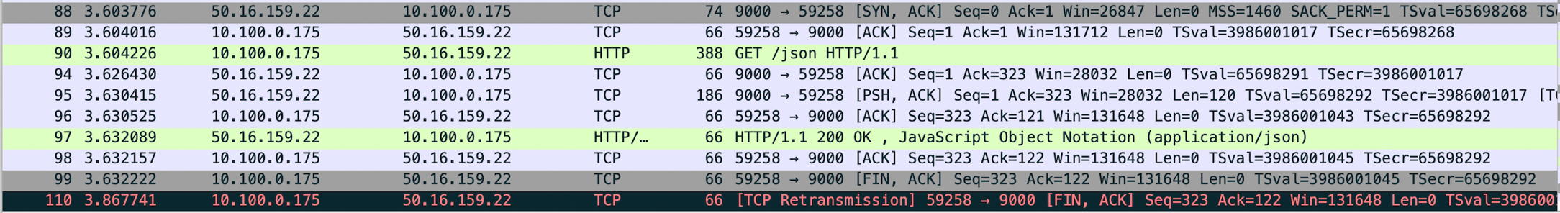

Figure 1: Refresh Button

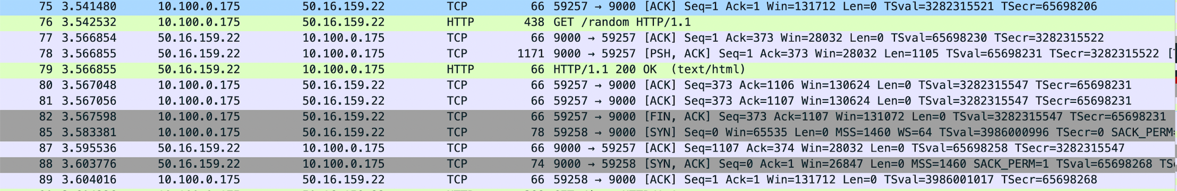

Figure 2:Random Button

1. What kinds of response codes are you able to get through different requests to your  
   server?
   1. 200 OK, JavaScript Object Notation (application/JSON)
   2. 200 OK (text/html)
   3. 400 Bad Request (text/html)
2. Explain the response codes you get and why you get them.
   1. 200 OK, JavaScript Object Notation (application/JSON)
      1. This is saying that the request is valid and was a success using the JSON notation. You get these when there is a request successfully made using JSON.
   2. 200 OK (text/html)
      1. This is saying that the request was valid and successful. You get this when the request that was made was a success.
   3. 400 Bad Request (text/html)
      1. This is an invalid request because of the syntax used. You get this when the syntax is wrong resulting to the server response being bad.
3. When you do an ipOfSecondMachine:9000 take a look what Wireshark generates as  
   a server response. Are you able to find the data that the server sends back to you?
   1. Yes. You are able to find the data that the sever sends back to you. You are able to see the host, the connection, cache-control, language, User-Agent, etc.
4. Based on the above question explain why HTTPs is now more common than HTTP.
   1. HTTPS is more common than HTTP because HTTPS uses encryption when sending data over the line.
5. What port does the server listen to for HTTP requests in our case and is that the  
   most common port for HTTP?
   1. Here we are using port 9000. This is not the most common port; the most common port is 80 for HTTP.
6. What local port is used when sending different requests to the WebServer? How  
   does it differ to the traffic to your SMTP server from part 1?
   1. For part 1, the local port was a different port number of 58612.

**3.4 Setting up a “real” Web server**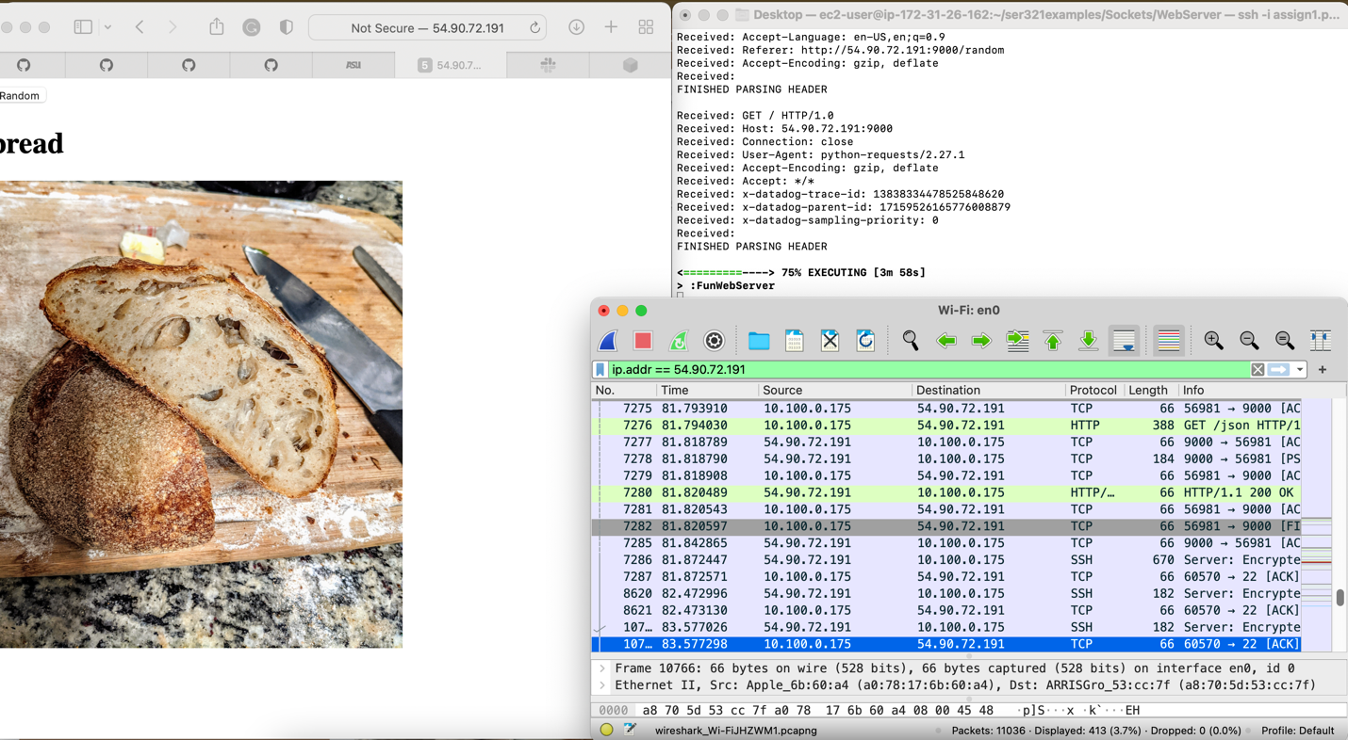

1. Check your traffic to your Webserver. What port is the traffic going to now? Is it  
the same as previously used or is it and should it be different?

The traffic is going to port 9000. This is different than what we previously saw.

2. Is it still HTTP or is it now HTTPs? Why?

Because we don’t have an SSL or TLS certificate, this is not HTTPS. So this is HTTP.

**3.6.1 Multiply**

I focused on errors that dealt with syntax. I included having valid argument names with the correct number of arguments and having valid integer values. Because all of these errors mentioned deal with syntax, I decided to use the error code 400 for a bad request. When this error code is run, it will explain the requirements for this code and provide an example as to what a proper input is. 